**Name**: Ahmed Ashade

**Course**: Building Secure Python Applications:

**Description**: This python program is a menu-driven python application with menu to

conduct some math and generate secure password

1. Test Cases

|  |  |  |  |  |
| --- | --- | --- | --- | --- |
| Test case | Input | Expected result | Actual result | Pass/Fail |
| Generate secure password | Select Option “a”  (default is 12): 12 | A Secure password generated | A Secure password generated | Pass |
| Generate Secure password | Select Option “a”  Enter: 'A1b2C3d4E!. | Invalid input: invalid literal for int () with base 10: 'A1b2C3d4E!. Please try again. | Invalid input: invalid literal for int () with base 10: 'A1b2C3d4E!. Please try again. | Pass |
| Calculate and format a Percentage | Select option “b”.  Enter: 45 and 90 | 50% | 50% | pass |
| How many days from today until July 4, 2025 | Select option “c”. | Number of days displayed | Number of days displayed | Pass |
| Use the law of cosines to calculate the leg of a triangle | Select option “d”. Enter a = 5, b=7, and c = 90degree | Length of the 3rd side displayed: 8.6 | Length of the 3rd side displayed: 8.6 | Pass |
| Calculate the volume of a right circular cylinder | Select option “e”. Enter r = 3, h = 5 | Volume = 141.37 cubic units | Volume = 141.37 cubic units | Passed |
| Exit program | Select option “f” | Program exits with message “Thank you for visiting the application. Goodbye! | Program exits with message “Thank you for visiting the application. Goodbye | Pass |
|  |  |  |  |  |
|  |  |  |  |  |
|  |  |  |  |  |
|  |  |  |  |  |

1. Testing Results of the program

**Menu**

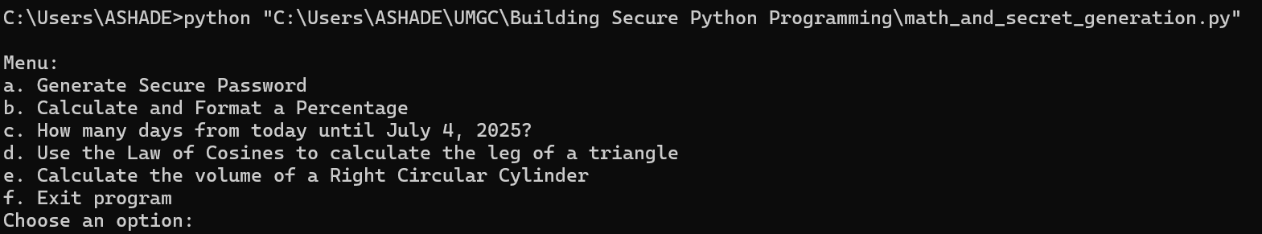

1. **Generate Secure Password**: Entered 12

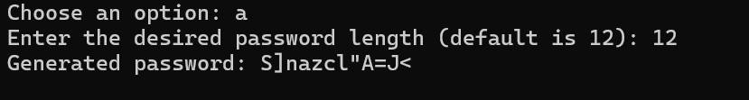

b. **Calculate and Format a Percentage**

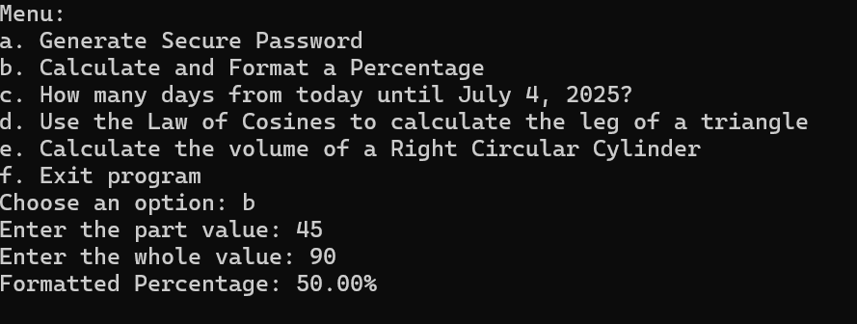

c. How many days from today until July 4, 2025?

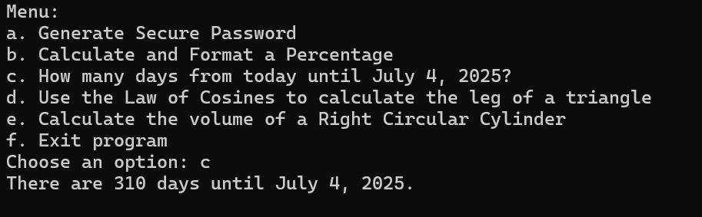

d. Use the Law of Cosines to calculate the leg of a triangle.

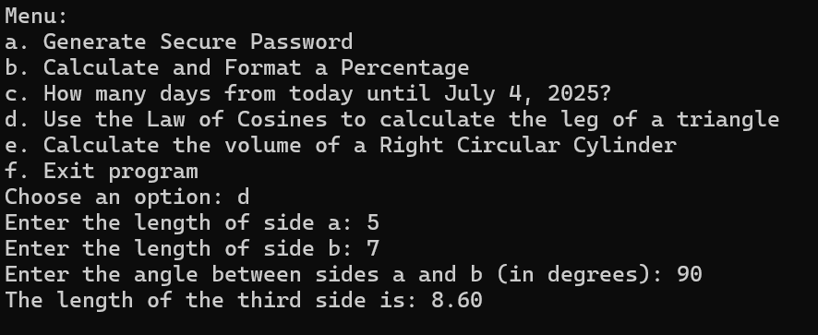  
e. Calculate the volume of a Right Circular Cylinder

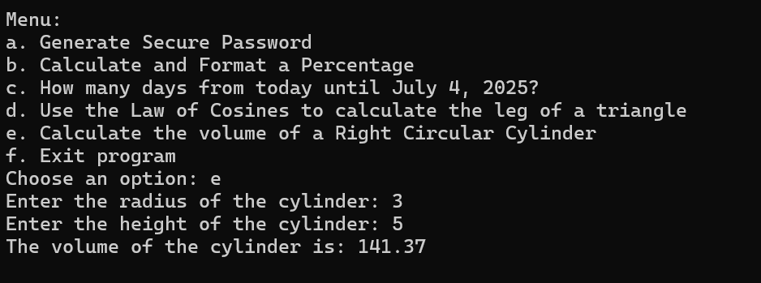

f. Exit program

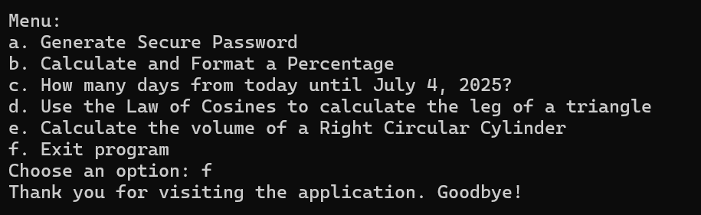

**Pylint Result**

1. **Run pylint on the "C:\Users\ASHADE\UMGC\Building Secure Python Programming\math_and_secret_generation.py"**

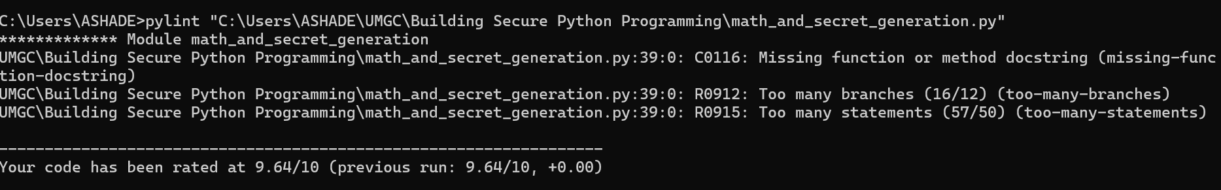

1. **I added some explanation to line 39, where C0116: Missing function or method docstring.**
2. 